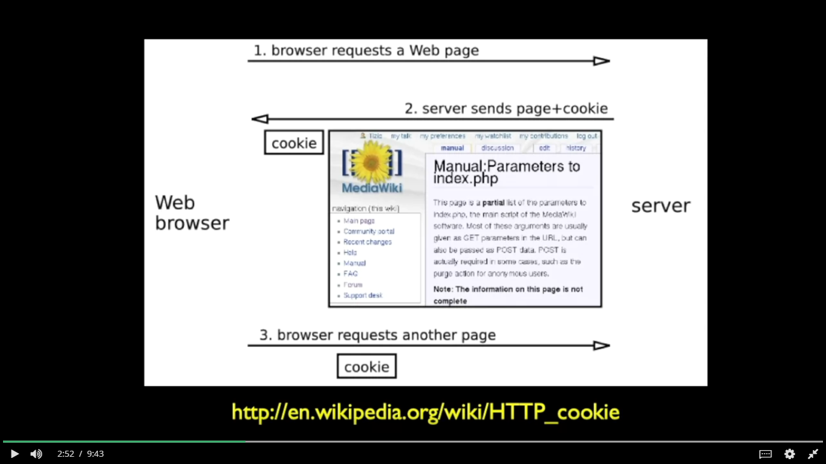

**Example 1(set, get, delete cookie):**

**views.py of app**

from django.http import HttpResponse

# Get Cookie

def get_cookie(request):

    cookie_value = request.COOKIES.get('name')

    if cookie_value:

        return HttpResponse(f"Cookie value: {cookie_value}")

        # return HttpResponse("Cookie value: "+cookie_value)

    else:

        return HttpResponse("Cookie not found!")

# Set Cookie

def set_cookie(request):

    response = HttpResponse("Cookie set!")

    response.set_cookie('name', 'django', max_age=15, secure=True)

    return response

# Delete Cookie

def delete_cookie(request):

    response = HttpResponse("Cookie deleted!")

    response.delete_cookie('name')

    return response

**urls.py of app**

from django.urls import path

from . import views

urlpatterns = [

    path('get-cookie/', views.get_cookie, name='get_cookie'),

    path('set-cookie/', views.set_cookie, name='set_cookie'),

    path('delete-cookie/', views.delete_cookie, name='delete_cookie'),

]

**urls.py of your project**

from django.contrib import admin

from django.urls import path, include

urlpatterns = [

    path('admin/', admin.site.urls),

    path('myapp/', include('myapp.urls')),

]

Now, run server

And then go to:

<http://localhost:8000/myapp/set-cookie/>

<http://localhost:8000/myapp/get-cookie/>

<http://localhost:8000/myapp/delete-cookie/>